**1. Commercial Banking Operations**

**2. Investment Banking Operations**

**(Presented By Alan Stuart K)**

**1. Commercial Banking Operations:**

**Introduction:**Commercial banking, also known as retail banking, involves providing a wide range of financial services to individuals, small businesses, and corporations. These services include accepting deposits, providing loans, offering savings and checking accounts, and other financial products. Commercial banks play a crucial role in the economy by facilitating financial transactions, providing credit, and managing financial assets.

**Basic Terminologies:**

1. **Deposits**: Funds placed into a bank account by customers. Deposits can be in the form of savings accounts, checking accounts, or fixed deposits.
2. **Loans**: Money lent by the bank to individuals or businesses with the expectation of repayment with interest. Common types of loans include personal loans, mortgages, and business loans.
3. **Interest Rate**: The percentage charged by the bank on loans or paid on deposits. It is a critical factor in determining the cost of borrowing and the return on savings.
4. **Credit Risk**: The risk that a borrower will default on their loan obligations. Banks assess credit risk to determine the likelihood of repayment.
5. **Liquidity**: The ability of the bank to meet its short-term obligations. High liquidity means the bank can easily convert assets to cash to meet withdrawal demands.
6. **Capital Adequacy**: A measure of a bank's financial strength, determined by its capital relative to its risk-weighted assets. Regulatory bodies set minimum capital adequacy ratios to ensure banks can absorb losses.
7. **Net Interest Margin (NIM)**: The difference between the interest income generated by the bank and the amount of interest paid out to depositors, relative to the amount of their interest-earning assets.
8. **Non-Performing Assets (NPA)**: Loans or advances for which the principal or interest payment remains overdue for a period of time. High NPAs indicate poor asset quality.
9. **Retail Banking**: Banking services provided to individual consumers rather than businesses. It includes services like savings accounts, personal loans, and credit cards.
10. **Corporate Banking**: Banking services provided to businesses and corporations. It includes services like business loans, treasury management, and trade finance.

**Graphs:**

**Graph 1.A:** Stock Prices for Commercial Banks:

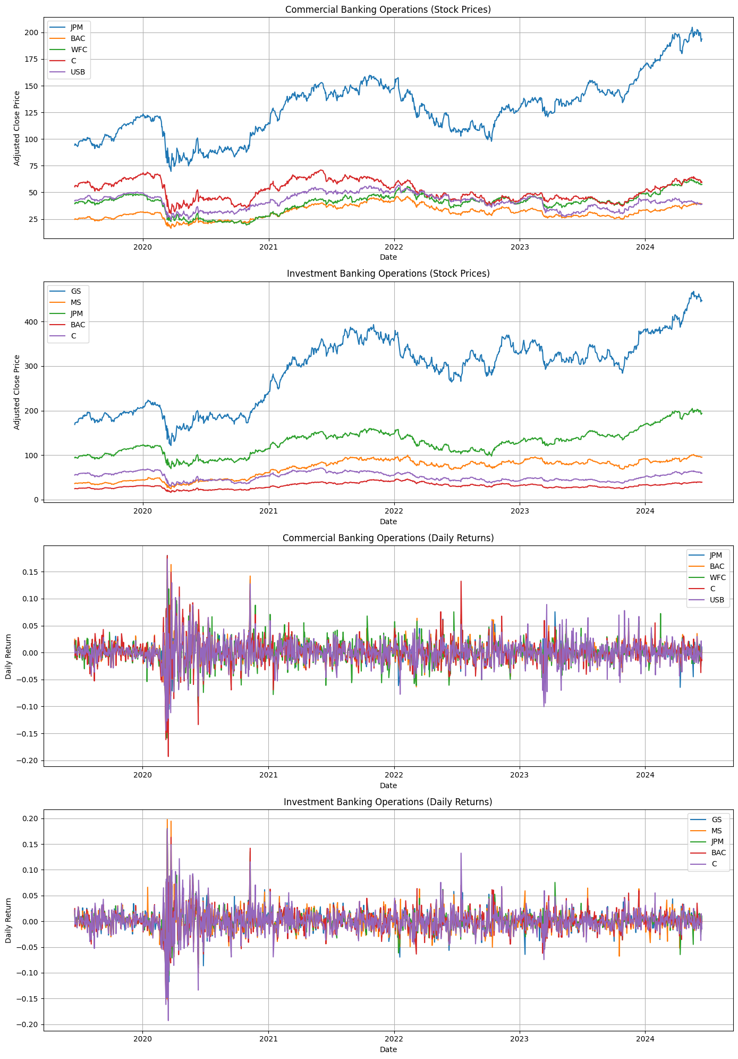**Inference**:

* **Trends**: You can observe the overall trend in stock prices for each bank. For instance, if the stock prices are generally increasing, it indicates positive market sentiment and potentially good financial health.
* **Volatility**: The fluctuations in the stock prices can give insights into the volatility of each bank's stock. Higher volatility might indicate higher risk.
* **Comparative Performance**: By comparing the stock prices of different banks, you can infer which banks have performed better or worse over the given period.

**Graph 1.B:** Daily Returns for Commercial Banks:

**Inference**:

* **Volatility**: Daily returns can provide a clearer picture of the volatility of each bank's stock. Higher daily returns variability indicates higher risk.
* **Market Reactions**: Sudden spikes or drops in daily returns can indicate market reactions to specific events, such as earnings reports, regulatory changes, or economic news.

**Graph 1.C:** Moving Averages for Commercial Banks:

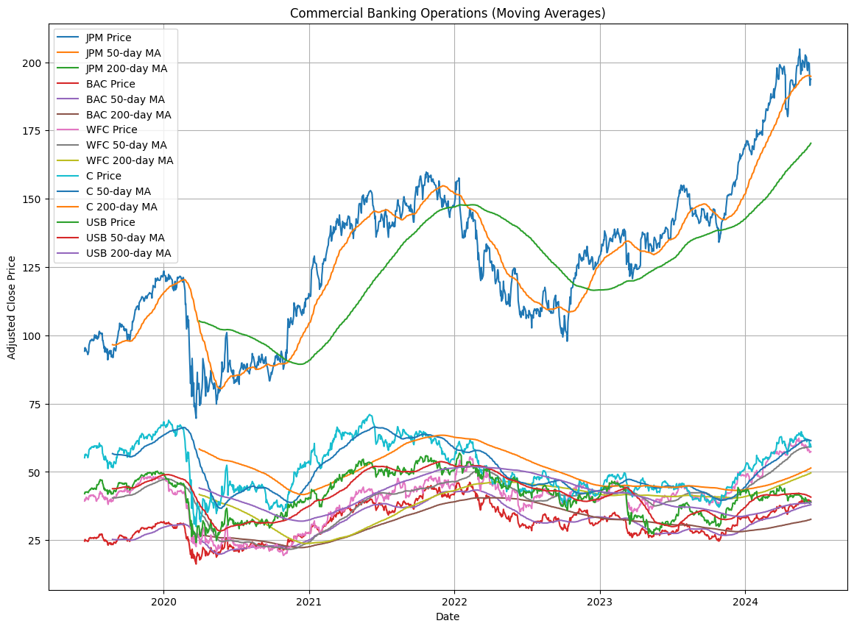**Inference**:

* **Trend Identification**: Moving averages help smooth out short-term fluctuations and highlight longer-term trends. If the 50-day MA is above the 200-day MA, it typically indicates an upward trend (bullish signal).
* **Support and Resistance**: Moving averages can act as support or resistance levels. Stock prices often bounce off these levels.
* **Crossovers**: When the 50-day MA crosses above the 200-day MA (golden cross), it is considered a bullish signal. Conversely, when it crosses below (death cross), it is considered a bearish signal.

**2. Investment Banking Operations:**

**Introduction:**  
Investment banking involves providing financial services to corporations, governments, and other institutions. These services include underwriting new debt and equity securities, facilitating mergers and acquisitions (M&A), providing advisory services, and managing investment portfolios. Investment banks play a vital role in capital markets by helping clients raise capital and navigate complex financial transactions.  
**Basic Terminologies:**

1. **Underwriting**: The process by which investment banks raise capital for clients by issuing new securities. The bank buys the securities from the issuer and sells them to investors.
2. **Initial Public Offering (IPO)**: The first sale of a company's shares to the public. Investment banks help companies go public by underwriting and marketing the IPO.
3. **Mergers and Acquisitions (M&A)**: The process of consolidating companies or assets. Investment banks provide advisory services to clients involved in M&A transactions.
4. **Equity Capital Markets (ECM)**: The division of investment banking that deals with the issuance and trading of equity securities. It includes IPOs, follow-on offerings, and private placements.
5. **Debt Capital Markets (DCM)**: The division of investment banking that deals with the issuance and trading of debt securities. It includes bonds, debentures, and other fixed-income instruments.
6. **Securities**: Financial instruments that represent ownership (equity) or a creditor relationship (debt) with an entity. Common securities include stocks and bonds.
7. **Leveraged Buyout (LBO)**: The acquisition of a company using a significant amount of borrowed money (leverage) to meet the cost of acquisition. The assets of the acquired company are often used as collateral for the loans.
8. **Hedge Funds**: Investment funds that employ various strategies to earn active returns for their investors. They often use leverage, derivatives, and short selling.
9. **Private Equity**: Investment in private companies or buyouts of public companies that result in the delisting of public equity. Private equity firms raise funds from institutional and accredited investors.
10. **Trading**: The buying and selling of securities, commodities, or other financial instruments. Investment banks often have trading desks that engage in market-making and proprietary trading.
11. **Advisory Services**: Services provided by investment banks to help clients with financial planning, strategy, and transactions. This includes M&A advisory, restructuring, and capital raising.
12. **Asset Management**: The management of investment portfolios on behalf of clients. Investment banks often have asset management divisions that offer mutual funds, pension funds, and other investment products.

**Graphs:**

**Graph 2.A:** Stock Prices for Investment Banks:

**Inference**:

* + **Trends**: Similar to commercial banks, you can observe the overall trend in stock prices for each investment bank.
  + **Volatility**: The fluctuations in the stock prices can give insights into the volatility of each bank's stock.
  + **Comparative Performance**: By comparing the stock prices of different investment banks, you can infer which banks have performed better or worse over the given period.

**Graph 2.B:** Daily Returns for Investment Banks:

**Inference**:

* + **Volatility**: Similar to commercial banks, daily returns can provide insights into the volatility of each investment bank's stock.
  + **Market Reactions**: Sudden spikes or drops in daily returns can indicate market reactions to specific events.

**Graph 2.C:** Moving Averages for Investment Banks:

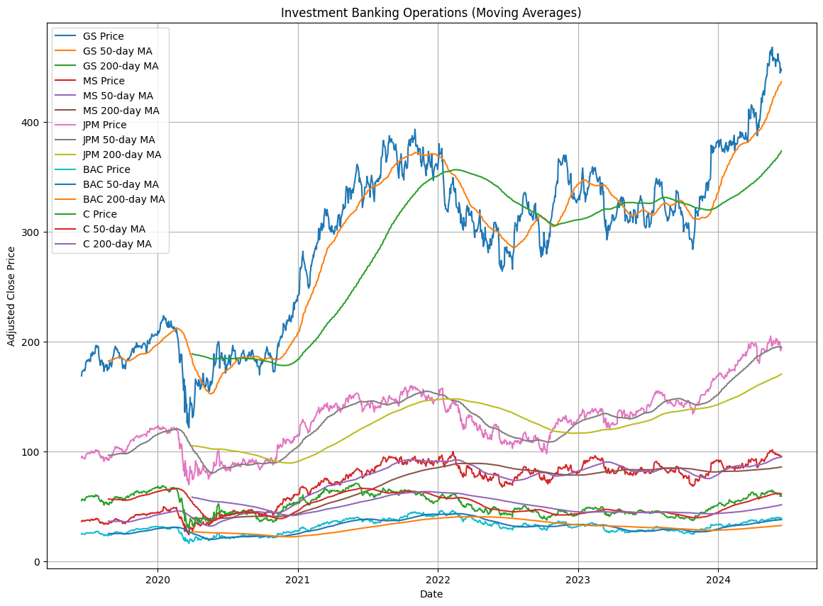**Inference**:

* + **Trend Identification**: Similar to commercial banks, moving averages help identify longer-term trends for investment banks.
  + **Support and Resistance**: Moving averages can act as support or resistance levels.
  + **Crossovers**: Golden crosses and death crosses can provide buy or sell signals.

**Conclusion:**

The US banking sector, encompassing both commercial and investment banking operations, is crucial for financial stability and economic growth. Commercial banks provide essential services like deposits, loans, and financial products to individuals and businesses, facilitating everyday transactions and supporting economic activities. Investment banks play a key role in capital formation, corporate restructuring, and financial advisory services, assisting clients with raising capital, mergers and acquisitions, and strategic advice. Together, these banks support economic growth and market stability. Analysing their performance and trends offers valuable insights into the sector's health and its broader economic impact, highlighting the importance of continuous monitoring and analysis for sustainable development.